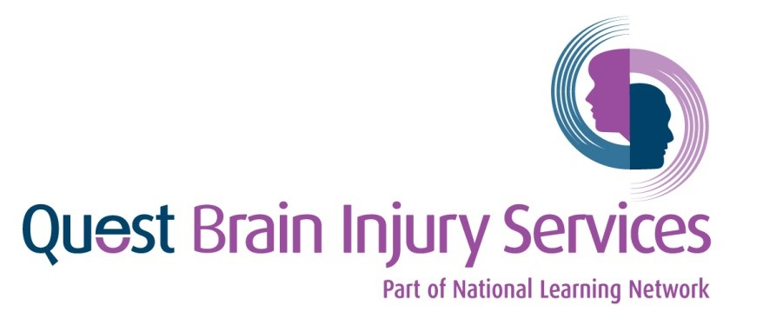
Programme Name: Quest Brain Injury Service 2021

APPLICATION FORM
for
Mayo and Roscommon

DATA PROTECTION STATEMENT – Individuals OVER 18 years of age
Name: __________________________
In compliance with the Data Protection Act 2018, The National Learning Network will keep personal information supplied to it only for lawful and specified purposes.
The National Learning Network will use your personal data for the purposes of processing your application, performing its obligations to you and to the funding authority in relation to providing training and related services and for general administration. Data will not be used or disclosed for any reason not compatible with these purposes.
Personal data relating to you will be processed in compliance with the Acts and will be stored in a secure, confidential and appropriate manner. The data will be stored only while it is relevant and will not be disclosed to a third party except with your consent or as required by law.
The Centre Manager/Co-Ordinator must make sure that each student/learner receives a copy of this document.
When the signed document is returned, it must be securely stored in a locked cabinet and produced immediately if required.
Personal Data
The National Learning Network is a Data Controller under the Data Protection Act 2018. The personal data that you supply to us is part of the registration process and is backed up by the Personal Data Processing Agreement.
We rely on you to provide us with accurate information and to inform us of any change in the information provided. Should you wish to update or access your personal data, you should write to the Data Protection Office and request a Data Subject Access Request Form.
I understand my rights under Data Protection Legislation, as outlined on this form

Applicant’s Signature: _________________________ Date: _______________________

Personal Details
Name: _____________________________ PPSN: __________________________
Address: ____________________________ Date of Birth: ___________________
___________________________________
___________________________________ Phone/Mobile: __
Eircode: _______________________ _____ email:___________________________
Emergency Contact(s)
Name: _______________________ Phone_______________ Relationship______________
Name: _______________________ Phone_______________ Relationship______________
Marital Status

Single | Married | Separated | Divorced | Widowed
If you have children or other dependents, please give details:

Current Situation
Please tell us about yourself, living alone with family etc.

Health
- Date of Brain Injury: ___________________
- Was there a loss of consciousness? Yes No
- What was the nature of the brain injury?
I consent to my Family Member/Significant Other being involved in my Rehabilitative Programme
Name: Yes No

Please give brief details of any other disability or health difficulty you may have:

Please describe how this affects you:
Please list any supports you think you may need (wheelchair access, interpreter, adaptive equipment, assistance with evacuation etc.)

Please list any medication you are taking and give details of any side effects:
Medication | Side Effects

Do you self-administer medication? Yes No
Do you require support to administer medication? Yes No
Do you have any allergies? Yes No
If Yes – give details
Please complete the following, in case of accident or illness
Name of GP: ____________________________
Address: ____________________________
____________________________
____________________________
Phone No: ____________________________

Please list any other professionals you are involved with:
(Consultant, Occupational Therapist, Social Worker, Community Health Nurse, Key Worker, etc)
Name: ____________________________ Name: _____________________________
Job Title: ____________________________ Job Title: _____________________________
Address: ____________________________ Address: _____________________________
____________________________ _____________________________
____________________________ _____________________________
Phone No: ____________________________ Phone No: _____________________________
____________________________ _____________________________

Referral Agent: (e.g. family member, GP, Psychologist)
Name: _____________________________ Job Title: ________________________
Address: ____________________________ Relationship _________________________
___________________________________ to Applicant: _________________________
Phone/Mobile: _______________________ email: _________________________
Social Welfare Benefits
Disability Allowance (DA) | Blind Persons Allowance
Invalidity Pension (IP) | Jobseeker’s Allowance (JA)
Jobseeker’s Benefit (JB) | One Parent Family Benefit
Other : Please give details | None
Are you receiving any of the following benefits?
Are you registered with SOLAS? Yes No
Do you have a Travel Pass? Yes No
Additional Information
Specialist Reports
What reports are available? Please provide copies if possible
General Medical | Community Care Assessment | Physiotherapy
Neurosurgical | Neuropsychological | Speech Therapy
Neurology | Employment Service | National Rehabilitation Hospital
Psychiatric | Occupational Therapy | Other Residential Service

In order to assist us in providing a Service that is able to match your needs, it may be necessary for us to contact various people external to this organisation to request information relevant to your current situation. We will only do this if it is deemed necessary, appropriate and applicable, in accordance with the Data Protection Act 2018.
I give my consent to Quest ABI Service to communicate with external bodies in support of my application.

Yes No

Applicant’s Signature: _________________________ Date: _______________________

Please return this completed form to:
The Manager
QUEST Brain Injury Services
9A Liosbán Business Park
Tuam Road
Galway

Mayo/Roscommon Outreach ABI SERVICES
STEP BY STEP APPLICATION PROCESS
Application
Application form received by Quest Brain Injury Services with clients consent to share information.
Reports will be requested from GP and other relevant health professionals.

Week

1

Week

2
Meeting

Meeting with applicant by Quest Brain Injury Outreach Services to determine if applicant is suitable for the services
Service orientation
Applicant is contacted by a member of Quest prior to screening. Information regarding the application process, Brain Injury and other related supports will be provided.

Week

6

Start date
Applicant is informed of service detail and start date.

Week

8

Onward referral
The intervention provided by Quest is time limited. Following completion of the Rehabilitative Programme onward referral and transition will occur as deemed appropriate.

