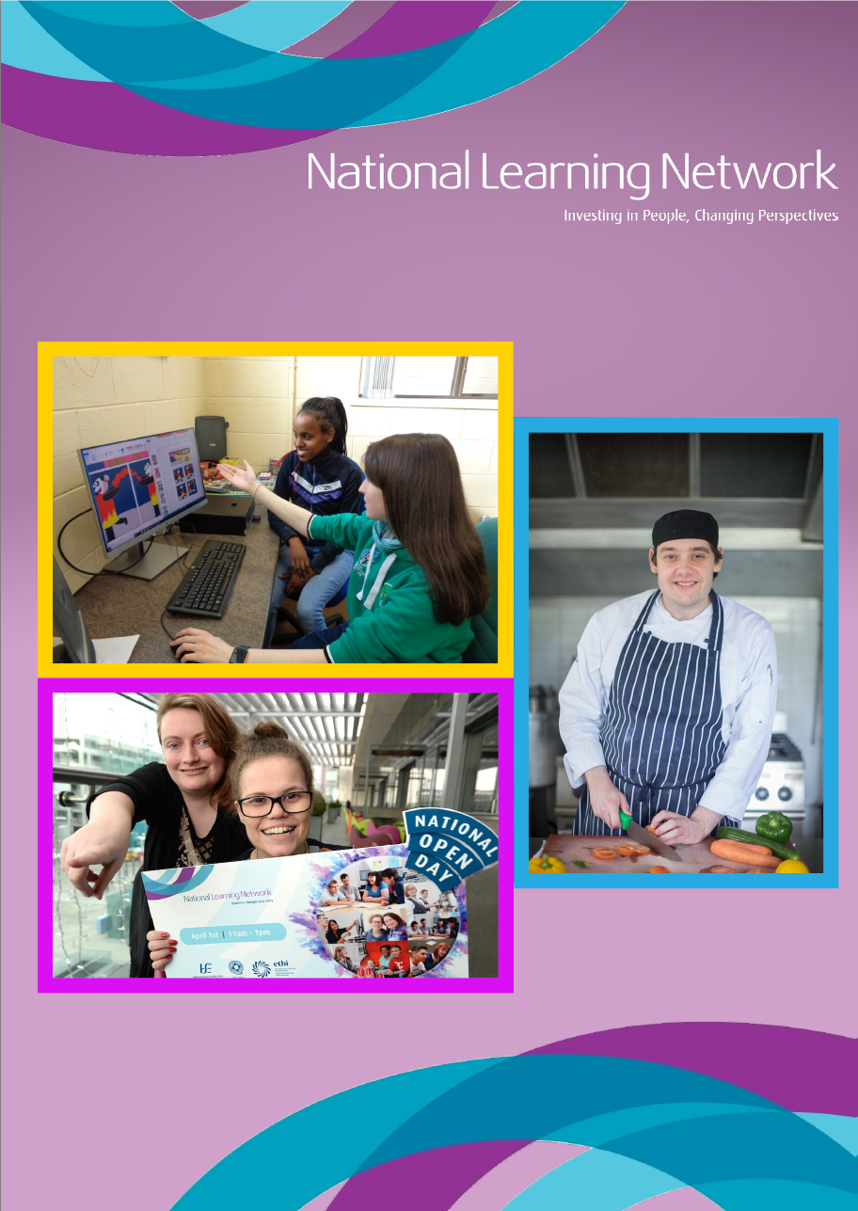
National Learning Network Submission to the Department of Justice and Equality on the Draft Youth Justice Strategy

Background
Who we are
National Learning Network (NLN) is the education and training division of the Rehab Group specialising in individualised, person-centred training and education with a specific focus on persons with disabilities. NLN caters for over 7,000 students each year, between the ages of 16 and 65 who have experienced a setback, an accident, a mental health issue, an illness, an injury or have a disability. We would see NLN playing a key role in being part of a holistic solution to diverting at-risk youth to education and employment, particularly at-risk young people with disabilities including people with autism, mental health issues and intellectual/cognitive disabilities.
One of our programmes, our ‘Stepping Out’ Programme, based in Athlone, provides education and training for ‘at risk’ people and those with a previous conviction to move into open employment and access further vocational training or higher education. The programme caters for around 80 people per year.
‘Stepping Out’ has been in operation for more than 20 years. Reducing reoffending is a core element of the programme, and further education/higher education and employment are the two key components which facilitate participants’ successful reintegration into the community. The Department of Justice and Equality is its primary funder. The Longford Westmeath Education and Training Board (LWETB) provides a valuable partnership in that they pay the training allowances to the participants. Although we cater for a wide range of ages on the programme, we have had many participants between the ages of 18 and 24.

What we do
Over the years, the ‘Stepping Out’ Programme has witnessed the benefits of an intense rehabilitative programme which can prevent criminal behaviour, as well as help participants become drug free. The participants on the programme are at all times given positive reinforcement as to the benefits of undertaking such a programme, including social integration and empowerment to participate fully within their own communities. Stepping Out’ provides support and training in three phases.
A Chartered Psychologist is specifically assigned to the ‘Stepping Out’ programme and this is seen as being a vital support for our participants. In phase 1, the psychologist meets with each participant prior to commencing the programme and produces a report which identifies their individual support needs. Issues which arise from the initial assessment include addiction issues (drugs and / or alcohol – often both), mental health issues, learning difficulties, social issues, relationship issues and homelessness. From these assessment, a plan or ‘individual action plan’ is drawn up to address these needs – some of which will be met by community services which we provide a referral service to.
Following this, the participant, if ready to engage in training commences phase 2 which means they join the structured programme which lasts for 12 months or longer if needed. The training programme can be attended on a full or part time basis. Upon completion of the programme, the participant enters into the post-training phase, where we continue to support the person should they relapse or be in need of our supports.
In 2019, on continuous intake, twenty-six trainees attended the structured programme and fifteen individuals attended the unstructured programme. There were four trainees who went on to further education. Two trainees secured full time employment. There was a 60% certification rate of QQI modules completed.
Our staff have a strong working relationship with the Probation Service, from whom we’ve received 109 referrals between 2018 and 2019 - local judges who refer clients, An Garda Síochána, local addiction counsellors, local GPs and mental health teams, and the LWETB.

Our Response to the Draft Youth Justice Strategy
We welcome the opportunity to provide the Department of Justice and Equality with a submission on the Draft Youth Justice Strategy.
Our expertise and recommendations relate to Thematic Object Two: Services for Children and Young People. We aim to highlight areas that are integral to ensuring the strategy’s success in prevention and want to emphasise the importance of early intervention, education and diversion of young people at risk of offending and those with a previous conviction.
From our experience in the Stepping Out Programme, the majority of our participants identified their first interaction with criminal activity occurring between the ages of twelve and fifteen. Therefore, in his submission we are particularly emphasising the importance of (i) Remaining in Education (ii) Early intervention and prevention for young people at risk of offending, and (iii) psychological supports. We also have some general suggestions on how the draft strategy can be improved.

Our Comments on the Draft Strategy
In our opinion, the needs of young people who have an intellectual disability (ID) who offend, or are at risk of offending, have not been fully incorporated into the Draft Strategy. While neurodiversity and mental health are referenced in the Strategy, there is no specific mention of Intellectual Disability or Cognitive Disability. Persons with these disability types are often at risk of coming into contact with the juvenile justice system and may not have an understanding of the consequences of their actions. These individuals are also highly at risk of being preyed upon by drug dealers. We have seen many times where young persons with intellectual disability have become involved in crime out of being targeted by drug dealers and becoming addicted to substances that they cannot afford to buy and therefore they become forced to ‘work’ for the drug dealer to pay off their debt. This forms a continuous cycle of crime and drug abuse. We ask that the Strategy is amended to be more inclusive of disability.
In addition, there is no mention of Irish Sign Language or easy read material in the draft strategy. This should be incorporated into the strategy.
We would also ask that the strategy commits to ensuring that all key staff who would be in contact with young people are provided with comprehensive training on disability awareness so that they are in a position to identify possible issues, possible need for supports and can deal with behaviour that challenges in an appropriate and sensitive manner.

Retention of young people with a learning difficulty in education
Most participants on the ‘Stepping Out’ Programme are early school leavers – one in ten has completed their Junior Certificate. At least two-thirds of our training group would normally present with a learning difficulty or disability. Some would have received a diagnosis in the past, but some would not have an official diagnosis. Many students who present at Stepping Out have learning difficulties ranging from dyslexia, Asperger’s Syndrome, mild intellectual disability to attention deficit hyperactivity disorder. Many participants would have gone through the formal education system with little educational support, resulting in them graduating with only a primary education or having progressed to secondary school but not achieved the Junior Certificate qualification.
As a specialised provider of education to persons with disabilities, NLN has vast experience of providing education and training for people with learning difficulties, intellectual disabilities behaviours of concern and people who marginalised and stigmatised in their communities. NLN’s holistic approach to assessment of need and identification of supports put an individual focus on each person’s barrier to progression, the supports required and the people or circle of support needed for each person. For young people at risk of offending it is this person-centred focus that puts meaningful plans in place with the supports to get positive results.
From our experience, we’ve identified that supports in schools for children and young people who present with learning disabilities are crucial for avoiding early attrition from school. These supports are made up of:
- Resource teachers
- Special Needs Assistants (SNAs)
- Peer support / social skills programmes
- Psychological support
Supports tend to be limited and underfunded, which leaves many young people behind in their education, particularly in numeracy and literacy. As their learning needs are not fully catered for in mainstream schools, they tend to leave formal education at a younger age than those who do not have a learning difficulty or an Intellectual Disability.
It is no coincidence then that some of the participants on the ‘Stepping Out’ programme are early school leavers with learning difficulties or an Intellectual Disability. Rates of mental health difficulties in the ID population already exceed those in the general population which further compounds the needs of these young people. The lack of service and support provisions to children and young people, in schools and in the community, is impacting their ability to progress in education. For example, services for young people with a diagnosis of Autism or Asperger’s Syndrome which can fall between the mental health team and the learning disability team – there is a huge gap here for adolescents and young adults.
The Draft Strategy has rightly identified that retention of young people in education is essential to prevent them from engaging in criminal activity. Therefore, it is essential that primary and secondary schools are provided with the funding and resource teaching / support staff to educate and support their students with Intellectual Disability and learning difficulties. This will ensure that young people can progress in education, and also reduce their likelihood of becoming involved in crime.

Addiction and Early Intervention
Another need arising for almost all of our participants are addiction issues. Often we meet participants who began using drugs as young as ten years old and alcohol at even younger ages.
Early intervention in primary and secondary schools need to highlight drug and alcohol addiction issues. General Practitioners and Community Alcohol Drugs teams and CAMHS (Child & Adolescent Mental Health Services) are crucial in preventing drug exploration from developing into an overwhelming addiction.
Drug and alcohol addiction can lead young people to criminal activity. In a recent survey with our participants, just over half stated that their drug taking led to a court appearance.
A welcome addition to the draft strategy would be a commitment to developing a junior ‘Stepping Out’ Programme for at risk early school leavers (ages 12-18) or to expand similar programmes.

Psychological Supports
Mental health services are vital supports for young people in education and diversion programmes. Some HSE Consultant Psychiatrists have expressed concern about the negative impact, now and into the future that Covid19 has had on an already overburdened mental health service. These services will find themselves overstretched and youth mental health services will be no different. Resourcing these services, which often play a preventive role in youth crime diversion, will be very important now.
The psychological supports in the Stepping Out programme prepare participants to enter into the programme, and support them if they relapse or require support in the post-training phase. Our person-centred, holistic approach, ensures that the person is surrounded by a support network from instructors, to GPs, to family and friends. This approach allows the participant to set their own goals, and take ownership of their training.

Our Recommendations to the Department of Justice and Equality

- Improve funding for educational supports for primary and secondary schools to keep young people with learning difficulties and Intellectual Disability in the formal education system so that their exposure to criminal activity is minimised.
- Focus interventions on all key transition points in each person’s life such as the transition from child and adolescent mental health services to adult mental health services and, in particular, the key transition period from primary to secondary schools.
- Implement an Early Intervention programme in schools and community centres to raise awareness around addiction to ensure drug and alcohol experimentation does not develop into addiction – again with a particular focus on the key transition period from primary to secondary school.
- Integrate people with Intellectual Disabilities and Sensory Disabilities into the plan, and make the strategy inclusive with easy read and ISL resources and materials.
- Direct funding and resources for psychological supports for young people into schools and early intervention and diversion programmes.
- Provide funding for comprehensive training of those staff that will be interacting with at risk youth about disability awareness, so they have an understanding of disability and use an appropriate approach.
- Consider developing a junior ‘Stepping Out’ Programme for at risk early school leavers (ages 12-18).
- Promote diversion to specialist education and training service such as National Learning Network, where appropriate to each person’s need. Our services may be appropriate for some young people at risk and we have a comprehensive assessment of need including risk assessment to ensure each person is matched to an appropriate service/training programme.

